Medtronic MITG
Research & Development

System Requirements Specification
Common Client v1.0

RE00026719 Rev C

Issue Date: Refer to Agile |  | Page 1 of 44
Revision History:
Revision | SDA | Description
A | RC026967 | Initial Release
B | RC051275 | Add Active Device Discovery, add chanpeter 7.9 to describe the targeting environment will be win10 & 7
C | RC086515 | Updated Section 6.6.2 to add CCFR 6.2 to address requirements from Risk Analysis
Author: Refer to Agile for approvals
Xishi Pan – InsigmaUS [Manual Approval]
Approvals: Refer to Agile for approvals
Paul Ourada – HI&MSystem Architect
Robert Boyer – VS System Architect
Ash Pandey – HI&M Product Owner
William Atkinson– QE, HI&M
Cliff Schorr – PMR QA

Table of Contents
1. Purpose 5
2. Scope 6
3. References 7
4. Glossary 8
5. Overview 9
5.1 Executive Summary 9
5.2 Common Client Architecture Overview 9
6. Functional Specification 11
6.1 User Authentication 14
6.1.1 Description 14
6.1.2 Unit Functions 14
6.2 Device Discovery and Dock 18
6.2.1 Description 18
6.2.2 Unit Functions 18
6.3 Device Virtual Dock 35
6.3.1 Description 35
6.3.2 Unit Functions 35
6.4 Device Feature Matrix 36
6.4.1 Description 36
6.4.2 Unit Functions 36
6.5 Schedule Job Report 37
6.5.1 Description 37
6.5.2 Unit Functions 37
6.6 Upgrade CC 38
6.6.1 Description 38
6.6.2 Unit Functions 38
7. Non-Functional Requirement 39
7.1 Security 39
7.2 Performance 39
7.3 Availability and scalability 39
7.4 Usability 39
7.5 Deployment 40
7.6 Flexibility 40
7.7 Backwards Compatibility 40
7.8 Internationalization 40
8. Appendix 41
8.1 Vital Sync Dependencies 41
8.2 GDMP Dependencies 42
8.3 Display Messages 43

Table of Figures
Figure 1 Common Client Architecture Overview 9
Figure 2 User Authentication Workflow 16
Figure 3 Devices List Page Mockup 18
Figure 4 Prep Screen Mockup 19
Figure 5 Facility Information Mockup 19
Figure 6 Retrieve Device List Work Flow (Standalone Mode) 20
Figure 7 Retrieve Device List Work Flow (Centralized Deployment Mode) 22
Figure 10 Pagination Mockup 22
Figure 11 Device Detail Mockup 23
Figure 12 Request Status Mockup 23
Figure 13 Devices Filter Mockup 23
Figure 14 Devices Search Mockup 23
Figure 15 Alert Message Mockup 24
Figure 16 Action Buttons Mockup 24
Figure 17 Sync Running Configuration Message Mockup 25
Figure 18 Request Status Mockup 25
Figure 19 Device Running Configuration Detail Mockup 26
Figure 20 Schedule Log Retrieval Mockup 27
Figure 21 Update Specific Software Now Mockup 30
Figure 22 Schedule Software Update Mockup 31
Figure 23 Schedule Software Update Mockup 32
Figure 24 Select Devices Mockup 34
Figure 25 Device Feature Matrix Mockup 36
Figure 26 Schedule Job Mockup 37

Purpose
The purpose of this document is to define the System Specification of Common Client system as a baseline of development and testing during the project cycle.

Scope
The scope of this document is limited to outlining the system specification for the Common Client only. The system specification for Vital Sync and GDMP are out of scope of this document.

References
[1] RE00022313 Rev D User Requirements Document CC v1.0

Glossary
Below is an alphabetized list of terms and acronyms used in this document with their corresponding definitions.
Acronyms | Description
CC | Common Client
GDMP | Gateway Device Management Platform, also known as DMP
MDT | Medtronic
VS | Vital Sync System
DMA | Device Management Agent also known as Agent or Gateway Agent

Overview

Executive Summary
The Common Client (CC) is a device servicing GUI tool, it will be used to upgrade device software, download device operation log, enable/disable features on the device(s) and synchronize configuration between GDMP and device(s) via Vital Sync. Its feature/functions availability is controlled by roles and access rights from both Vital Sync and Gateway Device Management Platform (GDMP).
Different from current client tools, the CC will support multi-tenancy and support both hosting model and individual model deployment. Also, it will address security concern troubling with current client tools and add some new features (such as schedule jobs).
This document consists of detailed feature/function specification based on “RE00022313 Rev A User Requirements Document CC v1.0” (User Requirements Document), these requirements are organized by functional and non-functional and details in chapter 4 and 5.
Finally, CC is not a standalone system, it highly depends on Vital Sync and GDMP, hence, the requirements to Vital Sync and GDMP are in chapter 6.

Common Client Architecture Overview
The Common Client is a software module that integrates the Vital Sync remote monitoring platform and the Gateway Device Management Platform (GDMP). The diagram below illustrates the high level components and their association.
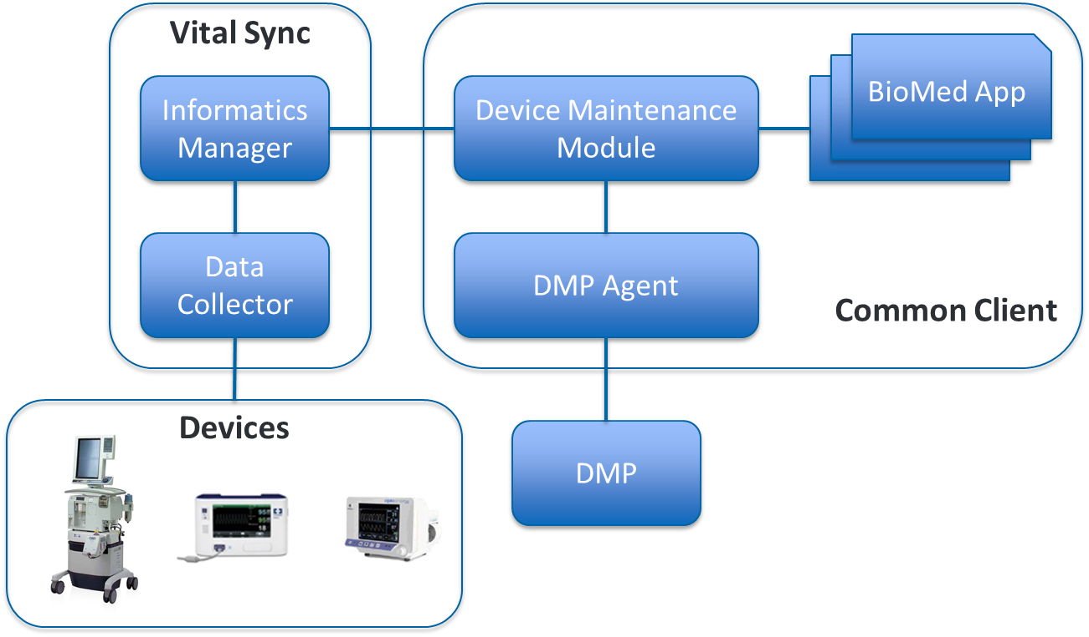
Figure 1 Common Client Architecture Overview
- DMP: The GDMP server is a cloud based server that is responsible for housing and propagating data to and from all of the DMAs.
- DMP Agent: This is the software that manages communication between the GDMP server and the Client Application. It is responsible for pulling and pushing data to the Vital Sync/GDMP for its supported devices.
- BioMed App: This is the UI the BioMed technician uses to manage their devices and push update and or requests to a device.
- Data Collector and Informatics Manager: These are the two Vital Sync components that talk to the physical devices.

Functional Specification

User Authentication

Description

Unit Functions
- CCFR 1.1: Displaying login page. The system will show the login page when user first get into the system. In standalone mode, user needs to type in GDMP username and password. In centralized deployment mode, user needs to type in Vital Sync username and password. Password only shows as **** on the page.
- CCFR 1.2: Processing Login. The CC uses different login method in standalone mode and centralized deployment mode.
  - CCFR 1.2.1: Processing Login in Centralized Deployment mode.
  - Vital Sync authentication. The system sends user credential to Vital Sync first. If the user credential cannot be validated, the system will show error message [Msg 1.1] to let user know that he doesn’t have the right username or password.
  - GDMP authentication. Once the user is authenticated in Vital Sync, Vital Sync will try to use its saved GDMP username and password hash to login to GDMP. When Vital Sync doesn’t have saved GDMP user credential or saved GDMP user credential isn’t correct, CC needs to ask user for the GDMP username and password. If the GDMP username or password is not correct, CC needs to ask user to retry. CC will also allow user to manage GDMP user account when GDMP user credential is requested by Vital Sync. Please refer to CCFR 1.4 for details.
  - Authorization. After user login succeeds, the system needs to get user role from Vital Sync. The user needs to have DeviceManagement rights in Vital Sync. If the user doesn’t have DeviceManagement rights, the system will display a message [Msg 1.2] to show user that he doesn’t have the appropriate rights. CC will also get user permission from Vital Sync during login.
If the login takes longer than a pre-configured time frame, the CC will display a system busy and still working message [Msg 1.3].
Figure 2 User Authentication Workflow (Centralized Deployment Mode)
  - CCFR 1.2.2: Processing Login in standalone mode. The CC sends user GDMP credential to Vital Sync. If the user credential cannot be validated, the system will show error message [Msg 1.1] to let user know that he doesn’t have the right username or password. After user is authenticated, CC will get user permission from Vital Sync.
- CCFR 1.3: Lock user account. If user retries Vital Sync credential too many times, user’s Vital Sync account will be locked by Vital Sync. Common Client will display error message [Msg 1.4]. If user retries GDMP credential too many times, user’s GDMP account will be locked by GDMP. Common Client will display error message [Msg 1.5]. User could reset their GDMP user account in the CC. User will have to contact Facility administrator to reset their Vital Sync user account in centralized deployment mode.
- CCFR 1.4: GDMP User Account Management. User could manage GDMP user account in CC. The user account management includes reseting user account, requesting user name and requesting user account. In the standalone mode, user could do this in the login page. In the centralized deployment mode, user could do this when user GDMP credential is requested by Vital Sync.
  - CCFR 1.4.1: Reset user account. When user click the Reset User Account button, the CC will pop up a new window with GDMP forgot password page embedded in it. The page still has Common Client header section.
- CCFR 1.4.2: Request user account. When user click the Request User Account button, the CC will pop up a new window with GDMP self registration page embedded in it. The page still has Common Client header section. CCFR 1.7: Timeout. The system will automatically log out after the user is idle for a certain time period which is configurable. The system will go back to the login page and display message [Msg 1.8]

Device Discovery and Dock

Description
The system needs to display devices. The figure below shows the device list page.
Figure 3 Devices List Page Mockup

Unit Functions
- CCFR 2.1: Prep Screen. Prep screen is only available for standalone mode. User needs to do the preparation steps after login. The preparation steps include downloading software packages and feature license files.
User needs to select facility first. For the third party technician, the facility list is limited to his responsibility defined in GDMP. If the user only has access to one facility, the CC will default to that facility. User doesn’t need to pick the facility in this case. For MDT technician, it would be the entire facility list. User could select multiple facilities.
Based on selected facilities, the device type selection will be populated. User could select multiple device types.
When user clicks the Apply button, the CC will do two things.
- For the selected device types, CC will download missing software package, register them in Vital Sync and send the package content to Vital Sync.
- For the selected facilities, CC will ask GDMP Agent to download available feature license files that are linked to those facilities. The downloaded feature license files will be stored on the GDMP Agent side.
CC needs to show the progress of the downloading on the prep screen. User doesn’t need to wait until the downloading finishes before closing the prep screen. The prep steps will continue to run. When the prep steps finish, it will also show a message in the alert area in the device list page.
If user doesn’t need to do any preparation steps, he could close the prep screen. He may need to select facility and country later when device is connected in standalone mode.
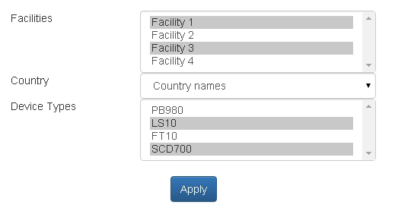
Figure 4 Prep Screen Mockup
The selected facility name needs to show on the device list page.
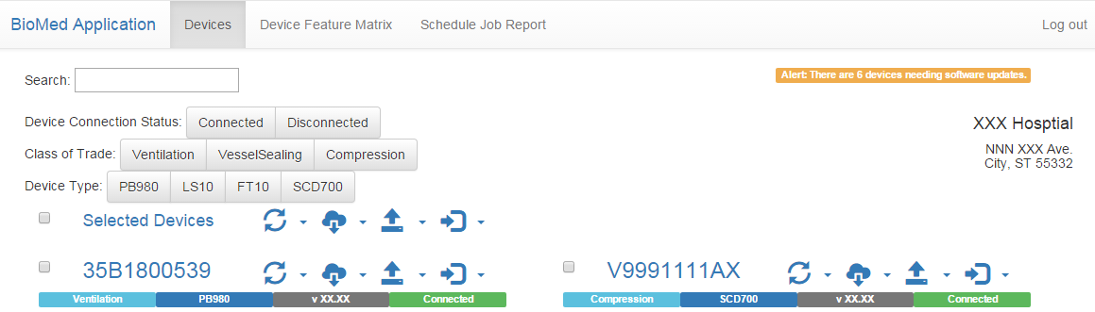
Figure 5 Facility Information Mockup
- CCFR 2.2: Retrieve device list.
  - In the standalone mode, CC only deals with connected devices from Vital Sync. The following work flow shows the process.
Figure 6 Retrieve Device List Work Flow (Standalone Mode)
- CC needs to check if the device type is valid in GDMP. If not, the device will be ignored.
- If the device type is valid, CC needs to check if facility and country is selected in the prep screen. One and only one facility needs to be selected before CC could sync running configuration for the device.
- If the facility or country is not selected, CC needs to pop up a window for user to select.
- After the facility and country is selected, CC needs to check if the device exists in GDMP.
- If the device doesn’t exist in GDMP, CC needs to create it in GDMP.
- If the device exists in GDMP, CC needs to get the running configuration and send it to GDMP.
- If GDMP detects that the facility is different from what’s in GMDP, CC will ask user to double check if facility is selected correctly. User could go back to prep screen to re-select facility if needed.
  - In the centralized deployment mode, facility and country are defined in the configured file during the deployment process. CC needs to retrieve three different data from Vital Sync and GDMP.
    - Device list from Vital Sync. It is all the devices that Vital Sync has ever connected to in the facility.
    - Device list from GDMP. It only contains the devices under the facility as far as GDMP knows.
    - Device type list from GDMP. It is the valid device types in GDMP.
Below is the work flow for retrieving device list.
Figure 7 Retrieve Device List Work Flow (Centralized Deployment Mode)
- CC uses GDMP device type list to filter the Vital Sync device list. CC only processes the devices with valid device type in GDMP.
- CC merges filtered Vital Sync device list with GDMP device list to get a unique device list. CC needs to display the devices from both lists.
- For Vital Sync connected devices and any devices that become connected, CC checks if they exist in GDMP.
- If device doesn’t exist in GDMP, CC will send a request to GDMP to create it.
- CCFR 2.3: Display device list. In the standalone mode, CC needs to display connected devices. In the centralized deployment mode, CC needs to display the devices on the Unique Device List (described in CCFR 2.2). The devices are sorted by device category, device type and serial number. The device detail information also shows up on the same page. Device detail information includes device category, device type, connection status, service status and last location. Device status is refreshed based on a configurable interval.
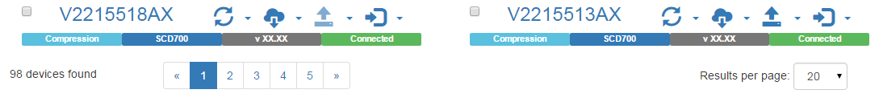
Figure 8 Pagination Mockup
  - CCFR 2.3.1 Pagination: CC needs to display total devices found. User is able to select number of devices to display per page.
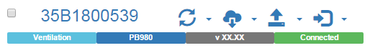
Figure 9 Device Detail Mockup
  - CCFR 2.3.2: Display request status. CC always displays the latest status message for each device when available in Vital Sync.
CC only displays one latest status message per device. New message will replace the old message. All status messages need to have timestamp. User could view historical device status in device status report.
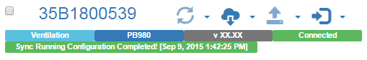
Figure 10 Request Status Mockup
- CCFR 2.4: Filter device. The CC has three filter items on the page. User could filter the devices based on
  - Device Connection Status
  - Device Service Status
  - Device Category
  - Device Type
  - Last Location
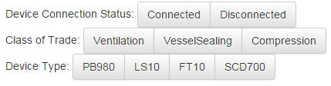
Figure 11 Devices Filter Mockup
- CCFR 2.5: Search device. The CC has a search text box on the device list page that user could search devices based on key word.

Figure 12 Devices Search Mockup
- CCFR 2.6: Alert message. The CC displays alert message in the following scenario.
  - CCFR 2.6.1: Software package update alert. The CC needs to display number of devices that have latest software package available for update. [Msg 2.22]
  - CCFR 2.6.2: Feature license update alert. The CC needs to display number of devices that have feature license to update. [Msg 2.23]
Figure 13 Alert Message Mockup
- CCFR 2.7: User actions. The CC shows all the following buttons for each device as disabled with “processing indicator” first when loading the page. The “processing indicator” means that the CC is calculating if the button needs to be enabled or disabled. Then the CC will retrieve device status and user permission to enable or disable the button based on criteria in an async mechanism. (User will see the page loaded, and the action icons will change to disabled or enabled once the particular feature/function available for this login).
The device status is refreshed based on a pre-configured interval, so the button may become enabled / disabled after the device status refreshed. The webpage itself shouldn’t refresh. User could use those buttons to perform different actions for different devices simultaneously.
If the user refreshes the page, the system shouldn’t recalculate the button status.
The button itself is just an icon. The tooltip of the button needs to show the button name. When the button is disabled, the tooltip also needs to show why the button is disabled based on the criteria.
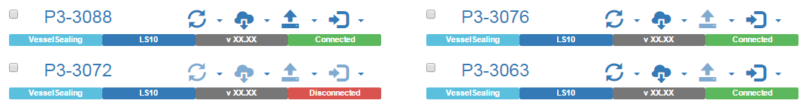
Figure 14 Action Buttons Mockup
  - CCFR 2.7.1: Sync Device Running Configuration button (). The button is enabled when the device meets the following criteria.
    - The device is connected.
The button needs to have the following behavior when user clicks it.
    - When user clicks the button, it needs to become disabled to prevent multiple clicks. The message [Msg 2.1] needs to show up under the device. The CC needs to send “Get running configuration” request to Vital Sync and check the response periodically. Once the request is finished successfully, the CC needs to send running configuration back to GDMP. The running configuration includes software configuration, hardware configuration, feature list, facility and country.
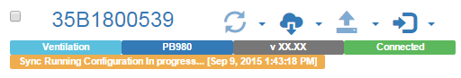
Figure 15 Sync Running Configuration Message Mockup
    - After the sync is finished successfully, the button becomes enabled again. The message [Msg 2.2] needs to show up under the device.
Figure 16 Request Status Mockup
    - If the sync process has some error, the button becomes available. Error message with timestamp [Msg 2.3] needs to show up under the device.
  - CCFR 2.7.2: View Device Running Configuration button (the drop down small arrow next tobutton). The button is enabled when the device meets the following criteria.
    - The device is connected.
The button needs to have the following behavior when user clicks it.
    - When user clicks the button, the system will pop up a new in-browser window to show “Device Running Configuration Detail” page for the detail running configuration.
The “Device Running Configuration Detail” page needs to show the following information for the device.
    - Configuration
      - Hardware configuration
        - Name
        - Revision
        - Description
      - Software configuration
        - Name
        - Version
        - Description
    - Feature
      - Feature name
      - Feature description
      - Feature license term
      - Status: Enabled/disabled
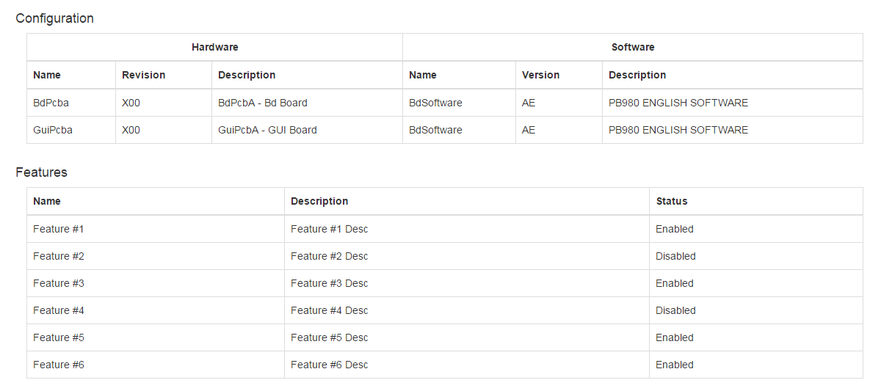
Figure 17 Device Running Configuration Detail Mockup
  - CCFR 2.7.3: Retrieve Log button (). The button is enabled when the device meets the following criteria.
    - The device is connected.
The button needs to have the following behavior when user clicks it.
    - When user clicks the button, it needs to become disabled. The message [Msg 2.4] with completion percentage needs to show up under the device.
For the devices with “Clean log” configuration in GDMP, the CC needs to pop up a warning message box before retrieving log.
The CC would send “Retrieve log” request to Vital Sync and check the response periodically. The log file will be sent back from Vital Sync in chunks. The CC will merge the chunks into the whole file and send to GDMP Agent. After the log is successfully sent back to GDMP Agent, the CC may need to send “Clean log” request to Vital Sync depends on device configuration.
GDMP Agent will encrypt and save the device logs locally up to a certain time period which is configurable. The certain time period is based on log retrieval date. So user is able to view the device logs via CC.
    - After the retrieving is finished successfully, the button remains disabled until it meets the criteria again. The message [Msg 2.5] needs to show up under the device.
    - If the retrieving process has some error, the button becomes available. Error message with timestamp [Msg 2.6] needs to show up under the device.
  - CCFR 2.7.4: Schedule Log Retrieval button (the drop down small arrow next tobutton). The button only shows up in the centralized deployment mode.
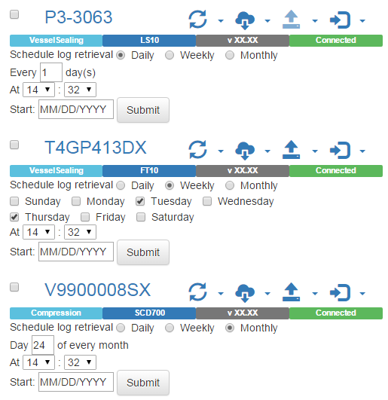
Figure 18 Schedule Log Retrieval Mockup
The button needs to have the following behavior when user clicks it.
    - When user clicks the button, the CC will display the scheduling section. User could schedule the log retrieval based on daily, weekly or monthly schedule. After user submits the schedule for the log retrieval, CC will send the scheduling information to Vital Sync. Vital Sync will retrieve log based on schedule. The CC will have a timer to retrieve the log from Vital Sync for all the scheduled devices based on a pre-configured time interval. User could also manually trigger this log retrieval process.
    - After the schedule is submitted, the successful message [Msg 2.7] needs to show up under the device.
    - If the schedule process has some error, the button becomes available. Error message with timestamp [Msg 2.8] needs to show up under the device.
    - The status of the log retrieval needs to show up in the activity report. So user could know when log is retrieved from Vital Sync.
  - CCFR 2.7.5: View Saved Log button (the drop down small arrow next tobutton). The button is enabled when the device meets the following criteria.
    - The device has saved log in GDMP Agent.
The button needs to have the following behavior when user clicks it.
    - When user clicks the button, the CC will pop up a new in-browser window to show “Device Log” page for the detail log.
The CC needs to retrieve saved log from GDMP Agent. Log needs to be decompressed or decoded if needed. Decoder will be provided by the device team.
Device Category | Device Type | Log Format | Decoder Needed
Patient Monitoring | MARVEL | TBD | TBD
Patient Monitoring | Vital Sync | Text/XML | No
ABLATION | Emprint planing software | TBD | TBD
Table 4 Log Format
The “Device Log” page needs to show the following information for the device. The date time needs to show in ISO format.
  - Log Name
  - Date & Time
  - Log Type
  - Serial No
  - Software Version
  - File Version
  - Log Entries
    - Date
    - Time
    - Event
    - Code
    - Type
    - Notes
When the saved log file is too big, Common Client displays the log content in multiple pages. Each page displays one chunk of the log file. The content is displayed as is. Common Client doesn’t format the log content. User could also download the entire log file.
If the log format is unknown, Common Client will inform the user that it cannot display the log content. User can still download the file.
  - CCFR 2.7.6: Register Missing Device Package button (). This will be used to download software package from GDMP and push it to Vital Sync. Even though the device package is registered for a particular device, the package will be available for all other devices with the same device type. User only needs to register the software package once for the device type. The button is enabled when following criteria are met.
    - GDMP has software available for updating the device type and the software package is not registered in Vital Sync. The CC needs to retrieve the entire software version list from GDMP and the registered software version from Vital Sync.
      - Class A user: GDMP has latest software package available for the device type and the latest software package is not registered in Vital Sync yet. The tooltip of the button needs to show current software version and latest software version.
      - Class B user: GDMP has any released software available for the device type and the software package is not registered in Vital Sync yet.
      - Class C user: GDMP has any released or un-released software available for the device type and the software package is not registered in Vital Sync yet.
    - User is trained for the device type.
The button needs to have the following behavior when user clicks it.
    - When user clicks the button, it needs to become disabled. When the package is being downloaded from GDMP, the message [Msg 2.9] with completion percentage needs to show up under the device. When the package is being sent to Vital Sync, the message [Msg 2.10] needs to show up under the device with completion percentage.
      - For Class A user, CC only registers missing latest software packages.
      - For Class B user, CC registers any missing released software packages.
      - For Class C user, CC registers any missing released or un-released software packages.
CC also needs to deregister software packages when they are archived in GDMP.
    - After the registering is finished successfully, the button remains disabled until it meets the criteria again. The message [Msg 2.11] with timestamp needs to show up under the device.
    - If the registering process has some error, the button becomes available. Error message [Msg 2.12] with timestamp needs to show up under the device.
  - CCFR 2.7.7: Update Latest Software Now button (the drop down small arrow next to). The button is enabled when the device meets the following criteria.
    - Vital Sync has latest software package registered and the software package is not updated on the device.
    - The device is connected. Some devices may only accept updates in service mode. When the device is not in service mode, the device may not accept the request.
    - User is trained for the device type.
The button needs to have the following behavior when user clicks it.
    - When user clicks the button, it needs to become disabled. The message [Msg 2.13] needs to show up under the device.
The CC would send “Update SW” request to Vital Sync and check the response periodically. The CC needs to display completion percentage when available. After the software update is finished successfully, the CC needs to sync running configuration automatically. The device itself will be the gatekeeper to handle multiple software update racing condition.
    - After the updating is finished successfully, the button remains disabled until it meets the criteria again. The message [Msg 2.14] needs to show up under the device.
    - If the updating process has some error, the button becomes available. Error message with timestamp [Msg 2.15] needs to show up under the device.
  - CCFR 2.7.8: Update Specific Software Now button (the drop down small arrow next to). The button is enabled when the device meets the following criteria.
    - User is Class B or Class C user.
    - Vital Sync has software package registered and the software package is not updated on the device.
      - Class B user: Vital Sync has any released software package registered and the software package is not updated on the device.
      - Class C user: Vital Sync has any released or un-released software package registered and the software package is not updated on the device.
    - The device is connected. Some devices may only accept updates in service mode. When the device is not in service mode, the device may not accept the request.
    - User is trained for the device type.
The button needs to have the following behavior when user clicks it.
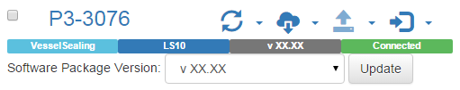
Figure 19 Update Specific Software Now Mockup
    - When user clicks the button, the CC will let user pick a specific software version to upgrade/downgrade. When the device has multiple software packages available, user needs to pick the software package first. User could only update one software package at a time. There would be a warning message box if user is going to downgrade the software package. The button needs to become disabled. The message [Msg 2.13] needs to show up under the device.
The CC would send “Update SW” request to Vital Sync and check the response periodically. The CC needs to display completion percentage when available. After the software update is finished successfully, the CC needs to sync running configuration automatically.
    - After the updating is finished successfully, the button remains disabled until it meets the criteria again. The message [Msg 2.14] needs to show up under the device.
    - If the updating process has some error, the button becomes available. Error message with timestamp [Msg 2.15] needs to show up under the device.
  - CCFR 2.7.9: Schedule Latest Software Update button (the drop down small arrow next to). The button only shows up in the centralized deployment mode. The button is enabled when the device meets the following criteria.
    - Vital Sync has latest software package registered and the software package is not updated on the device.
    - User is trained for the device type.
The button needs to have the following behavior when user clicks it.

Figure 20 Schedule Software Update Mockup
    - When user clicks the button, the CC will let user to pick a date to update the software. The update will happen when next time the device is available for service on/after the picked date. The date could be today or later. After the schedule is submitted, the message [Msg 2.16] / [Msg 2.17] need to show up under the device. One device could only have one schedule for software update. User could reschedule the software update. It will override the existing schedule.
      - When there is an existing schedule for the latest software update, the CC needs to display the current schedule. The “Submit” button becomes “Modify”. An extra “Cancel” button also shows up to cancel the existing schedule.
      - When there is an existing schedule for the specific software update, the CC needs to show a warning message. User could still submit the schedule to override the existing one.
When user submits the software update schedule, the CC would send “Update SW” request with schedule to Vital Sync and check the response periodically. After the software update is finished successfully, the CC needs to sync running configuration automatically.
    - If the scheduling process has some error, the button becomes available. Error message with timestamp [Msg 2.18] needs to show up under the device.
  - CCFR 2.7.10: Schedule Specific Software Update button (the drop down small arrow next to). The button only shows up in the centralized deployment mode. The button is enabled when the device meets the following criteria.
    - User is Class B or Class C user.
    - Vital Sync has software package registered and the software package is not updated on the device.
      - Class B user: Vital Sync has any released software version registered and the software package is not updated on the device.
      - Class C user: Vital Sync has any released or un-released software version registered and the software package is not updated on the device.
    - User is trained for the device type.
The button needs to have the following behavior when user clicks it.

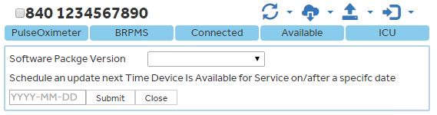
Figure 21 Schedule Software Update Mockup
    - When user clicks the button, the CC will let user pick a specific software version to upgrade/downgrade. When the device has multiple software packages available, user needs to pick the software package first. User could only update one software package at a time. There would be a warning message box if user is going to downgrade the software package. The CC will also let user pick a date to update the software. The update will happen when next time the device is available for service on/after the picked date. The date could be today or later. After the schedule is submitted, the message [Msg 2.16] / [Msg 2.17] need to show up under the device. One device could only have one schedule for software update. User could reschedule the software update. It will override the existing schedule.
      - When there is an existing schedule for the latest software update, the CC needs to show a warning message. User could still submit the schedule to override the existing one.
      - When there is an existing schedule for the specific software update, the CC needs to display the current schedule. The “Submit” button becomes “Modify”. An extra “Cancel” button also shows up to cancel the existing schedule.
When user submits the software update schedule, the CC would send “Update SW” request with schedule to Vital Sync and check the response periodically. After the software update is finished successfully, the CC needs to sync running configuration automatically.
    - If the scheduling process has some error, the button becomes available. Error message with timestamp [Msg 2.18] needs to show up under the device.
  - CCFR 2.7.12: Update Feature License button (). The button is enabled when the device meets the following criteria.
    - GDMP latest feature license available for the device.
    - The device is connected.
    - User is trained for the device type.
The button needs to have the following behavior when user clicks it.
    - When user clicks the button, it needs to become disabled. The message [Msg 2.19] needs to show up under the device.
The CC will get the feature license package from GDMP, send to Vital Sync with “Update Feature License” request and check response periodically. The feature license file shouldn’t be saved locally. Once the request is finished successfully, the CC will sync running configuration automatically. After the license file is fully sent to Vital Sync, CC needs to let GDMP Agent know that it is the time to delete the file on GDMP Agent side.
    - After the updating is finished successfully, the button remains disabled until it meets the criteria again. The message [Msg 2.20] needs to show up under the device.
    - If the updating process has some error, the button becomes available. Error message with timestamp [Msg 2.21] needs to show up under the device.
  - CCFR 2.7.12.1: Feature License Auto Update. There is a configuration on the device type level in GDMP to indicate if the device type is eligible for feature license auto update. When the device is eligible for feature license auto update and the CC is centralized deployed, the CC will check if there is any feature license available based on a pre-configured time interval. If so, CC will apply the feature license without human interaction. The result of the auto update needs to show up in the device status report on GDMP side. It also needs to show up as part of CCFR 2.3.2 Display Request Status.
  - CCFR 2.7.13: View Features button (the drop down small arrow next to button). The button is enabled when the device meets the following criteria.
    - The device is connected.
The button needs to have the following behavior when user clicks it.
    - When user clicks the button, the system will pop up a new in-browser window to show “Device Features” page for enabled / disabled features and the features available for enable / disable.
The CC needs to get purchased feature list from GDMP and feature enabled/disabled status from Vital Sync.
The “Device Features” page needs to show the following information for the device.
    - Feature name
    - Feature description
    - Feature license term
      - Permanent (From GDMP)
      - Limited
        - Remaining Count ( From Vital Sync) / Total Count (From GDMP)
        - Time based (Termination Date (From GDMP))
    - Status: Enabled/disabled
    - Purchase Status: Available for Enable/Disable
- CCFR 2.8: User actions for Multiple Devices. User is able to select multiple devices to perform the same action. The action button is enabled only when all the selected devices meet the criteria. The CC keeps selected result when user switches pages. The CC clears selected result when user search or filter devices. A message box with selected device list will pop up right after user clicks the action button. So user would have a chance to confirm the action for multiple devices.
Here are the actions that available for multiple devices.
  - Sync Running Configuration
  - Retrieve Log
  - Schedule Log Retrieval
    - When there is any existing schedule, the CC will show warning message.
  - Update Latest Software Package Now
  - Schedule Latest Software Package Update
    - When there is any existing schedule, the CC will show warning message.
  - Update Feature License
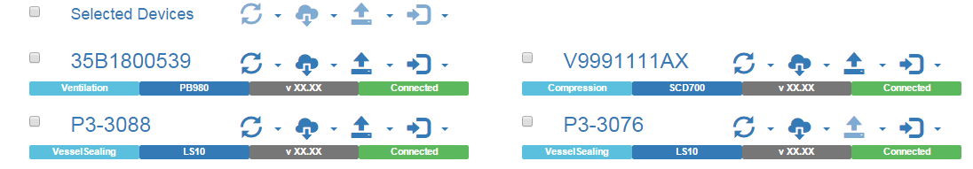
Figure 22 Select Devices Mockup
CCFR 2.9: Active Device Discovery. In standalone mode, user may connect to some devices that need active device discovery. User needs to click the active device discovery button to trigger the process.
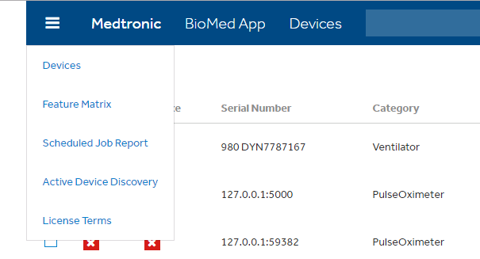
Figure 23 Active Device Discovery Button Mockup
After user clicks the button, the system will popup a window with device type list. The device type list is retrieved from Vital Sync. User could only see the device types that he has access to. User needs to pick one or multiple device types to trigger the active device discovery. The system will show a message when the device discovery is finished.

The “Active Device Discovery” button only appear for selection when there is device can be activly discoved to the user’s current login session. If the current login session has no any device required for active device discovery, the “Active Device Discovery” will be hided.

The following diagram shows the workflow for the desired device discovery among all systems:
Figure 24: Active Device Discovery Workflow

Device Virtual Dock

Description
When CC is in standalone mode, devices get docked when they are connected. When CC is centralized deployed, devices are connected all the time. So they need to be docked virtually. This chapter describes the virtual dock.

Unit Functions
- CCFR 3.1: Device Virtual Dock. When CC is centralized deployed, it virtually docks all connected devices based on a pre-configured time interval. The docking process includes sync running configuration, register missing software package. User is able to view the status of these operations in the status report.

Device Feature Matrix

Description
User is able to view feature status for all devices under the facility on one page.

Unit Functions
- CCFR 4.1 Display device type dropdown list. The CC is able to display device type dropdown list for user to choose device type first. The device type is concatenated with device category, underscore and device type (e.g. VesselSealing_LS10).
- CCFR 4.2: Display feature matrix. User needs to select device type first. The CC will display feature status for the devices under the facility.
The matrix columns include
  - Device serial number
  - Software Version
  - Features
  - Status: Enabled / Disabled / Not Available / Purchased
User could click column header to sort or filter the matrix.
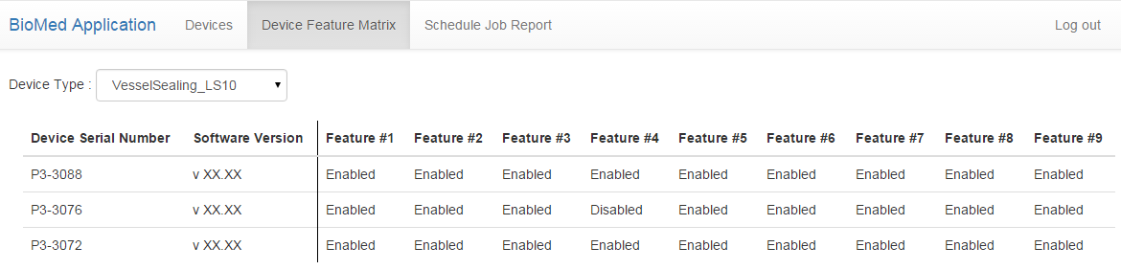
Figure 25 Device Feature Matrix Mockup

Schedule Job Report

Description
User is able to view all the schedule jobs for the facility.

Unit Functions
- CCFR 5.1: Display schedule jobs. The CC is able to display all the scheduled jobs different devices within the facility.
The report columns include
  - Device serial number
  - Device category
  - Device type
  - Job Type
  - Schedule
User could click device serial number to go back to "Devices" page to perform operations for the device.
User could click column header to sort or filter the report.
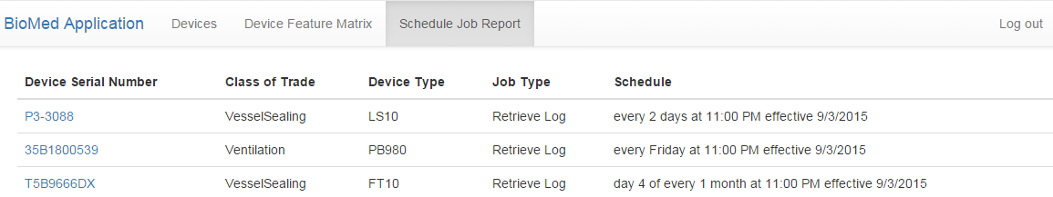
Figure 26 Schedule Job Mockup

Error Messages

Description
When there is a error, the CC will redirect user to the error message page.

Unit Functions
- CCFR 6.1: Display error message. When there is any system error, the CC is able to redirect user to the error message page to show user friendly error message.
- CCFR 6.2: If a failure occurs from a user intiated action such as SW update, Log Retreval, etc., the failure message should be displayed so that the user is aware of the failure and can acknowledge the failure message.

Upgrade CC

Description
The CC should be able to check newer version and alert user. User will decide the best time to do the upgrade or decide not to upgrade.

Unit Functions
CCFR 7.1: Show Upgrade Message. When CC is in standalone mode, it should be able to show message when new version is available.
CCFR 7.2: Report CC Version Number. When user logs in, CC needs to report its own version number together with its own serial number to GDMP. It will treat CC as a device and sync running configuration for CC. The CC running configuration includes
- Hardware configuration
  - CPU
  - Memory
  - Operating System
- Software configuration
  - CC version
CC serial number

Non-Functional Requirement

Security
CCNFR 7.1: All the following data needs to be encrypted when saving locally or communicating with Vital Sync and GDMP Agent.
CC should not save any temp data, it will always uses streaming as the communication channel when exchange data with Vital Sync and GDMP Agent.
- Device configuration
  - Device configuration shouldn’t be saved locally.
  - Device configuration needs to be encrypted during the communication with Vital Sync and GDMP Agent.
- Device log
  - Device log shouldn’t be saved locally.
  - Device log needs to be encrypted during the communication with Vital Sync and GDMP Agent.
- Software package
  - Software package shouldn’t be saved locally.
  - Software package needs to be encrypted during the communication with Vital Sync and GDMP Agent.
- Feature license
  - Feature license shouldn’t be saved locally.
  - Feature license needs to be encrypted during the communication with Vital Sync and GDMP Agent.

Performance
CCNFR 7.2: A single instance of the Common Client shall allow at least 25 concurrent users to service up to 500 distinct devices each at a given time simultaneously.

Availability and scalability
CCNFR 7.3: Availability and scalability only subjected to centralized deployment and it will align with Vital Sync.

Usability
CCNFR 7.4: The CC needs to provide mobile capability.
The smallest width that CC will support is 320 pixels on mobile devices.
The laptop browsers that CC will support are IE9, IE 10, IE 11, Chrome version 42 and up, Safari 9.0, Firefox 41.0.
The mobile browsers that CC will support are Safari on iOS 9.0 and Chrome on Android 6.0.

Deployment
CCNFR 7.5: Common client needs to support centralized deployment model, with this deployment model, CC will act as a Web Server, and all users will remote login to the CC via a web browser. In this deployment model CC will be deployed together with Vital Sync and GDMP Agent on the facility server.
CCNFR 7.6: Common client needs to support deployed as a standalone mode, with this deployment mode, it will be deployed on a laptop with GDMP Agent and necessary Vital Sync component only. Common Client also needs to support silent installation.

Flexibility
CCNFR 7.7: The system shall have the capability to present to users special workflow if needed for specific device types for all service related tasks.

Backwards Compatibility
CCNFR 7.8: The system shall not impact legacy versions of GDMP and Vital Sync, although CC will not work with legacy versions of GDMP and Vital Sync. The existing client application shall still be able to use GDMP as usually.

Internationalization
CCNFR 7.9: The system shall be able to support multi-language.

Targeting running environment
CCNFR 7.10: The CC needs to be deployed and run on Windows 10 and Windows 7.

Appendix

Display Messages
- User Authentication
  - User name or password incorrect message.
    - English: Username or password is not correct.
  - Not enough rights message.
    - English: User doesn’t have appropriate rights to login.
  - Login process slow message.
    - English: Login in progress…
  - User account locked message.
    - English: Your user account is locked.
  - Reset account password request sent message.
    - English: Your user account reset request has been sent. Please check your email later.
  - Username request sent message.
    - English: Your username request has been sent. Please check your email later.
  - User account request sent message.
    - English: Your user account request has been sent. Please check your email later.
  - Time out message.
    - English: Your account has been logged out.
- Device Discovery
  - Sync running configuration in progress message
    - English: Sync running configuration in progress… [Timestamp]
  - Sync running configuration completed message
    - English: Sync running configuration completed! [Timestamp]
  - Sync running configuration failed message
    - English: Sync running configuration failed! [Timestamp] [Detail error message]
  - Retrieve log in process message
    - English: Retrieve log in progress… [Timestamp] [completion percentage]
  - Retrieve log completed message
    - English: Retrieve log completed! [Timestamp]
  - Retrieve log failed message
    - English: Retrieve log failed! [Timestamp] [Detail error message]
  - Schedule log retrieval completed message
    - English: Schedule log retrieval completed! [Timestamp]
  - Schedule log retrieval failed message
    - English: Schedule log retrieval failed! [Timestamp] [Detail error message]
  - Download device software package in progress message
    - English: Download device software package in progress… [Timestamp]
  - Register device software package in progress message
    - English: Register device software package in progress… [Timestamp]
  - Register device software package completed message
    - English: Register device software package completed! [Timestamp]
  - Register device software package failed message
    - English: Register device software package failed! [Timestamp]
  - Update device software package in progress message
    - English: Update device software package in progress… [Timestamp]
  - Update device software package completed message
    - Update device software package completed! [Timestamp]
  - Update device software package failed message
    - Update device software package failed! [Timestamp]
  - Schedule device software package update (next service mode) completed message
    - English: Schedule device software update in next service mode completed! [Timestamp]
  - Schedule device software package update (specific date) completed message
    - English: Schedule device software update on [MM/DD/YYYY] completed! [Timestamp]
  - Schedule device software package update failed message
    - Schedule device software package failed! [Timestamp]
  - Update feature license in progress message
    - English: Update feature license in progress… [Timestamp]
  - Update feature license completed message
    - English: Update feature license completed! [Timestamp]
  - Update feature license failed message
    - English: Update feature license failed! [Timestamp]
  - Software package update alert message
    - English: Alert: There are x devices needing software update.
  - Feature license update alert message
    - English: Alert: There are x devices needing feature license update.

